Goal-Based Investment Calculator
Hackathon Documentation – FinCal Innovation (Technex’26)

Problem Statement
Many investors struggle to understand how much they should invest monthly to achieve future financial goals such as education, travel, home purchase, or retirement milestones. Traditional calculators are often complex and difficult to interpret. The Goal-Based Investment Calculator aims to simplify this process by converting a future financial goal into a clear monthly investment requirement while considering inflation and expected investment returns.

Solution Overview
The proposed calculator provides a simple and interactive interface where users enter a few financial inputs and instantly receive an estimate of the monthly investment (SIP) required to achieve their goal. The calculator focuses on investor education by demonstrating the impact of compounding, inflation, and disciplined investing over time.

Key User Inputs
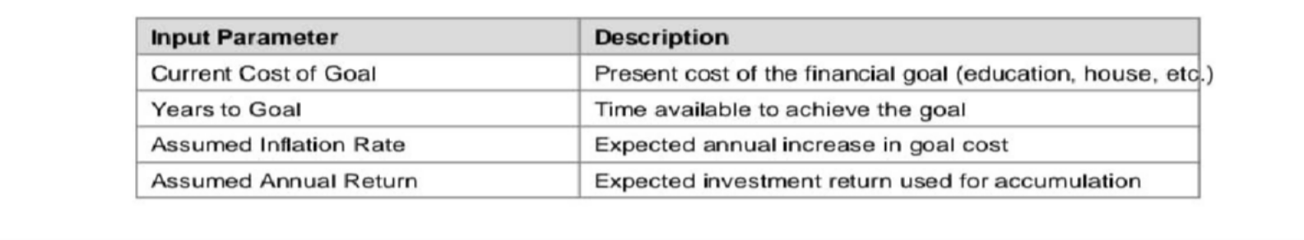

4.Financial Calculation Logic
Step 1 – Inflate Goal Value
Future Goal Value = Present Cost × (1 + Inflation Rate) ^ Years

This step estimates the future cost of the goal after considering inflation. Step 2 – Calculate Required Monthly SIP
Monthly Rate (r) = Annual Return ÷ 12 Total Months (n) = Years × 12
Required Monthly SIP = FV × r ÷ [((1 + r)^n − 1) × (1 + r)]
Where: FV = Inflated future goal value, r = Monthly return rate, n = Total number of months

Example Scenario
Example: A user wants to fund a 10,00,000 education goal in 10 years with: • Inflation assumption: 6% • Expected investment return: 12% Step 1 inflates the goal cost to determine the required future value. Step 2 calculates the monthly SIP

needed to accumulate that amount over 120 months. The calculator dynamically
performs these calculations and displays the required monthly investment.

User Experience Design
To make the calculator intuitive and engaging, the interface focuses on: • Simple sliders or input fields for financial variables • Instant result updates when inputs change • Visual representation of goal growth and SIP contributions • Clear display of assumptions used in calculations

Technology Architecture
Frontend: Next.js (interactive UI and responsive components) Backend: Node.js compatible services for calculation logic Database: MySQL (optional storage of scenarios) CMS Compatibility: Drupal integration if required

Accessibility and Responsiveness
The calculator follows WCAG 2.1 AA accessibility standards including: • Semantic HTML for screen readers • Proper ARIA roles for UI elements • Keyboard navigation support • Accessible form labels and validation • Adequate color contrast The UI is fully responsive and optimized for desktop, tablet, and mobile devices.

Compliance and Educational Purpose
The calculator is designed strictly for educational and investor awareness purposes. All financial assumptions are transparent and user-editable. Outputs are illustrative estimates and must not be interpreted as financial advice or guaranteed investment outcomes. Disclaimer: This tool has been designed for information purposes only.
Actual results may vary depending on various factors involved in capital markets. Investors should not consider the output as a recommendation for any scheme. Past performance may or may not be sustained in the future and is not a guarantee of future returns.

Usage : Deployed in Indian Railway

https://creative-prosperity-production.up.railway.app/

